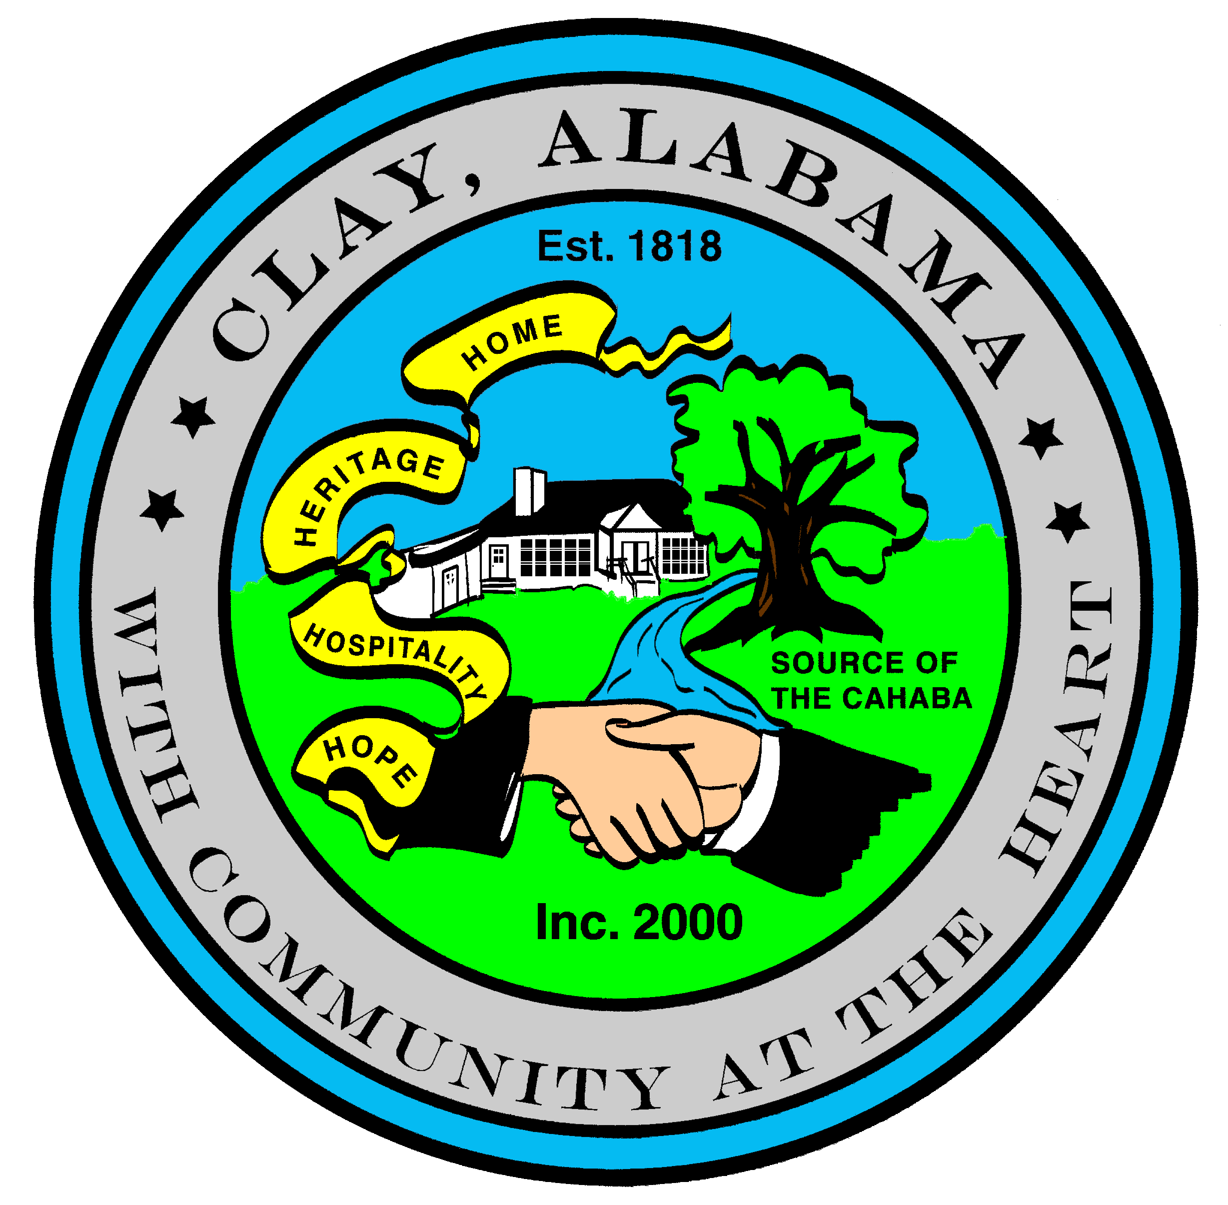
City of Clay
P.O. Box 345
Clay, AL 35048-0345
www.clayalabama.org

AGENDA
CITY COUNCIL MEETING
July 18, 2016
- Call to Order

- Prayer

- Pledge to the Flag

- Roll Call

- Approval of minutes
Pre-Council and Regular Council Minutes: July 5, 2016
- Approve Agendas
Approve Meeting Agenda
Approve Consent Agenda (Financial)

- Mayor and Council Comments
  - Mayor Webster
  - Councilor Baker
  - Councilor Becky Johnson
  - Councilor Bo Johnson
  - Councilor Small
  - Councilor Thackerson

- Reading of Petitions, Applications, Complaints, Appeals, Communications, etc.

- City Manager’s Report/Auditing Accounts
Bid Opening, Demolition, 7535 Old Springville Road
- Public Hearings
Public Hearing, Weed Abatement
5139 Darlene Drive
5328 Balboa Avenue
5518 Old Springville Road
5800 Chickadee Circle

- Resolutions, Ordinances, Orders, and other business
Resolution 2016-27 A Resolution Releasing the Lien for Abatement of Weeds at the property located at
6927 Mountain View Drive North East
Resolution 2016-28 A Resolution Authorizing the Elimination of a Nuisance Upon Private Property
Resolution 2016-29 A Resolution Declaring Weeds to be a Public Nuisance

- Public Comments

- Adjourn
Next City Council Meeting – Monday, August 1, 2016, 6:30 pm.

