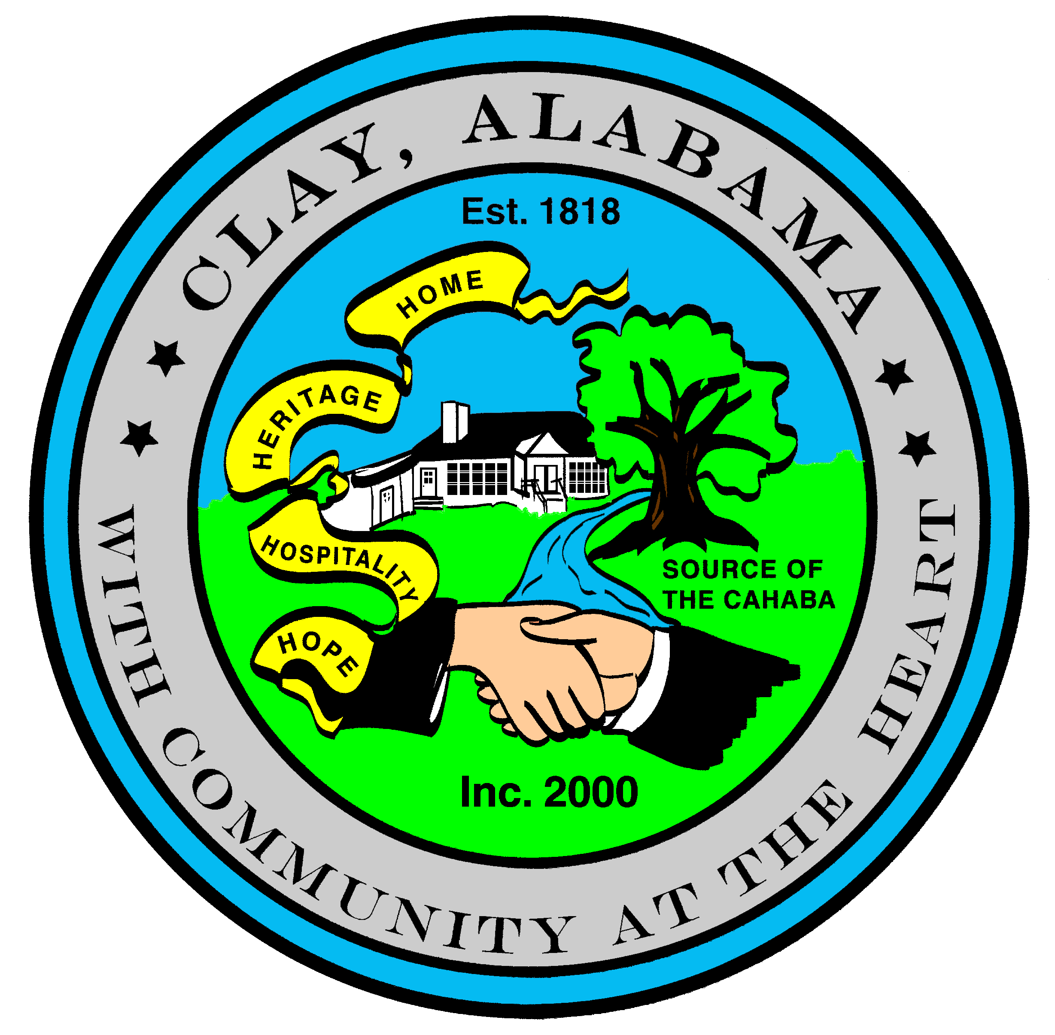
City of Clay
P.O. Box 345
Clay, AL 35048-0345
www.clayalabama.org

AGENDA
CITY COUNCIL MEETING
June 6, 2016
- Call to Order

- Prayer

- Pledge to the Flag

- Roll Call

- Approval of minutes
Pre-Council and Regular Council Minutes: May 19, 2016
- Approve Agendas
Approve Meeting Agenda
Approve Consent Agenda (Financial)

- Mayor and Council Comments
  - Mayor Webster
  - Councilor Baker
  - Councilor Becky Johnson
  - Councilor Bo Johnson
  - Councilor Small
  - Councilor Thackerson

- Reading of Petitions, Applications, Complaints, Appeals, Communications, etc.

- City Manager’s Report/Auditing Accounts
- Public Hearings
Public Hearing Condemn 7550 Misty Lane
Public Hearing, Condemn 7535 Old Springville Road
- Resolutions, Ordinances, Orders, and other business
Resolution 2016-19 A Resolution to Condemn and Authorize Demolition of Unsafe Buildings and/or
Structures
Resolution 2016-20 A Resolution to Condemn and Authorize Demolition of Unsafe Buildings and/or
Structures
Resolution 2016-21 A Resolution Releasing the Lien for Abatement of Weeds at 6926 Katelyn Circle

- Public Comments
- Adjourn
Next City Council Meeting – Monday, June 20, 2016, 6:30 pm.

