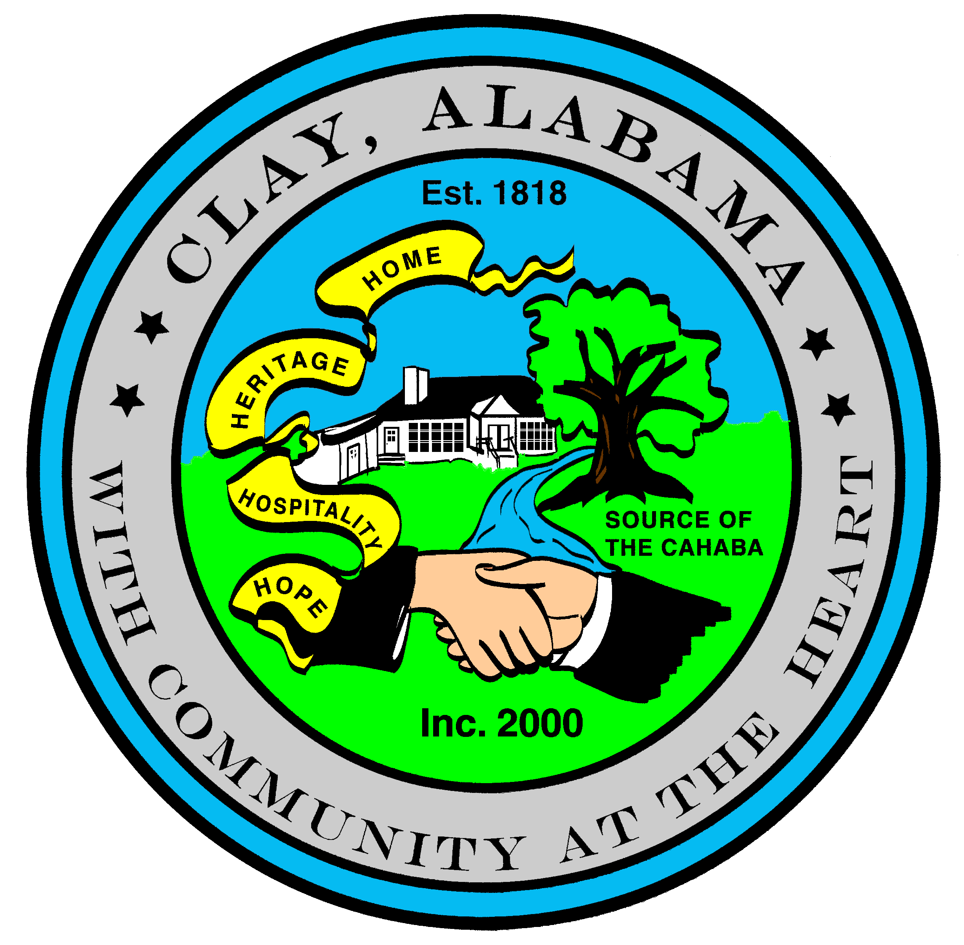
City of Clay
P.O. Box 345
Clay, AL 35048-0345
www.clayalabama.org

AGENDA
CITY COUNCIL MEETING
May 19, 2016
- Call to Order

- Prayer

- Pledge to the Flag

- Roll Call

- Approval of minutes
Pre-Council and Regular Council Minutes: May 2, 2016
- Approve Agendas
Approve Meeting Agenda
Approve Consent Agenda (Financial)

- Mayor and Council Comments
  - Mayor Webster
  - Councilor Baker
  - Councilor Becky Johnson
Proclamation 2016-01, A Proclamation Recognizing Teacher of the Year
  - Councilor Bo Johnson
  - Councilor Small
  - Councilor Thackerson

- Reading of Petitions, Applications, Complaints, Appeals, Communications, etc.

- City Manager’s Report/Auditing Accounts
- Public Hearings
Z-16-04, 6620 Trussville Clay Road
Z-16-05, 7410 Old Springville Road
- Resolutions, Ordinances, Orders, and other business
Resolution 2016-11 A Resolution to Contract with Greater Birmingham Humane Society for Animal Control
and Pound Services
Resolution 2016-12 A Resolution Appointing the City Manager to Perform the Duties for Holding a Municipal
Election as Required by State Law
Resolution 2016-13 A Resolution Releasing the Lien for Abatement at 7858 Bridget Circle
Resolution 2016-14 A Resolution Abating Weeds on the Property Located at 5118 Rick Drive
Resolution 2016-15 A Resolution Abating Weeds on the Property Located at 7739 Clayton Cove Parkway
Resolution 2016-16 A Resolution Abating Weeds on the Property Located at 7763 Clayton Cove Parkway
Resolution 2016-17 A Resolution Abating Weeds on the Property Located at 8053 Lizmore Lane
Resolution 2016-18 A Resolution Abating Weeds on the Property Located at 8054 Lizmore Lane
- Public Comments
- Adjourn
Next City Council Meeting – Monday, June 6, 2016, 6:30 pm.

